Haven Database
As
signm
ent
Pre-implementation Design Review
ERD Subsection · Schema Design · PL/SQL Plan
Aayush Pun Prerak Oli Prajwol Timilsina Gyanesh Thapa
Project: CSY2093PJ1 | June 2025
Submitted for review prior to SQL implementation
Assignment Overview
This document presents the pre-implementation design review for the Haven Database assignment (CSY2093PJ1). It covers three preparation stages: selecting an appropriate ERD subsection, designing the database schema, and planning PL/SQL automation objects — all completed before writing the final SQL script.
Assignment Requirement | How This Plan Addresses It
Select ~5 ERD tables | Chosen tables: guest, programme, retreat_accommodation, retreat_setting, review
Design schema & skeleton tables | Columns, primary keys, foreign keys, and relationships defined for each table
Determine data extraction methods | Reports using joins, counts, SUM, and AVG calculations planned
Identify PL/SQL automation targets | Procedures, functions, triggers, cursor, UDT, and collection types listed
Describe each PL/SQL object | Every object is named and described before coding begins
List naming conventions | Convention table covers tables, procedures, functions, triggers, cursors, and types
NOTE
Confirm that the 5-table subsection and simplified bridge-table design are acceptable before implementation starts.
STEP 1
ERD Review and Table Selection
The first step is to study the original ERD and choose a connected subsection large enough to demonstrate relationships and PL/SQL automation, but focused enough for a clear implementation. The selected route follows the guest booking and feedback flow within the Haven system.
Selected 5-Table Scope
guest
customer details
programme
chosen programme
retreat_accommodation
stay option
retreat_setting
retreat & environment
review
rating & feedback
Flow: A guest books a programme → programme links to a retreat accommodation option → accommodation belongs to a retreat setting → reviews are recorded for that retreat setting.
Table | Reason for Selection | Assignment Value
guest | Holds customer and guest details including contact information. | Supports insert procedures, guest lookup queries, and booking links.
programme | Records a guest's chosen programme with date, cost, and booking status. | Central table for booking logic, status updates, cost functions, and income reports.
Table | Reason for Selection | Assignment Value
retreat_accommod ation | Links each programme to the specific accommodation used at the retreat. | Enables joins between programme data and retreat details; supports usage reporting.
retreat_setting | Represents the retreat type (e.g. health, weight loss) and its environment. | Supports retreat-level reporting and connects accommodation options to reviews.
review | Stores star rating, review title, description, and submission date. | Used for rating validation triggers, review procedures, and average rating functions.
ERD Reference — Original Haven Entity Relationship Diagram
The original ERD includes: accommodation_style, accommodation, setting, retreat, retreat_setting, retreat_accommodation, practice, practice_guide, programme, guest, guide, team, address, and review. The five selected tables (highlighted in the flow above) cover the guest-to-feedback path and provide sufficient complexity for the assignment.
ERD domain notes: practice types include mindfulness, yoga, crystals, HIIT; retreat types include rest and relaxation, weight loss, health, exercise; settings include lakeside, woodland, coastal, eco-friendly; accommodation styles include cabin, teepee, luxury, rustic, treehouse.
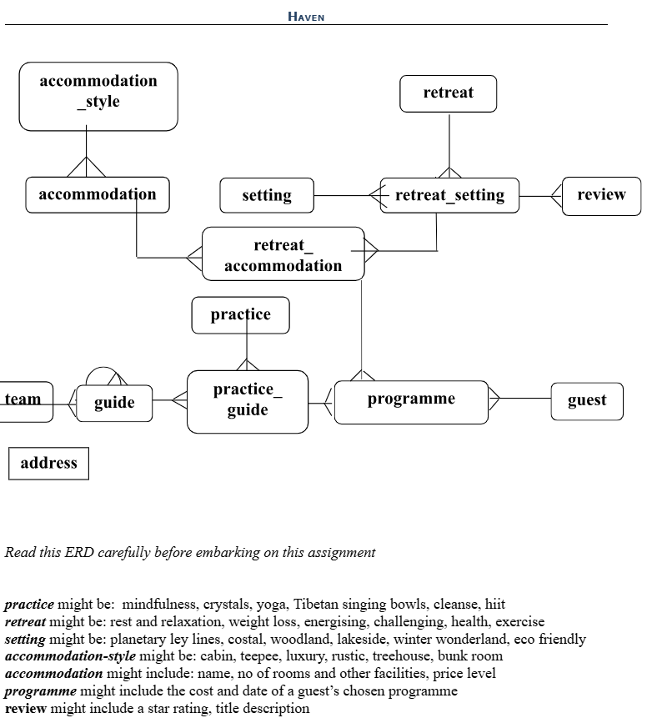
STEP 2
Database Schema Design
The five selected tables are now translated into a concrete schema. Each table is defined with column names, data types, constraints, and foreign key links to other tables.
Primary Key and Foreign Key Relationships
guest
PK: guest_id
programme
P
K: programme_id
FK: guest_id
FK: retreat_accommodation_id
retreat_accommodation
P
K: retreat_accommodation_id
FK: retreat_setting_id
retreat_setting
P
K: retreat_setting_id
review
P
K: review_id
FK: retreat_setting_id
Relationship | Cardinality | Meaning
guest → programme | One-to-Many | One guest can hold multiple programme bookings; each programme belongs to exactly one guest.
programme → retreat_accommodation | Many-to-One | Each programme uses one accommodation option; one option can be used by many programmes.
retreat_accommodation → retreat_setting | Many-to-One | Each accommodation option belongs to one retreat setting.
retreat_setting → review | One-to-Many | One retreat setting can receive many reviews; each review is tied to one retreat setting.
Table 1 — guest
Column | Data Type | Constraint | Description
guest_id | NUMBER | Primary Key | Unique identifier for each guest record.
first_name | VARCHAR2(50) | NOT NULL | Guest's first name.
last_name | VARCHAR2(50) | NOT NULL | Guest's last name.
email | VARCHAR2(100) | UNIQUE | Guest email address — unique to prevent duplicate registrations.
phone | VARCHAR2(20) | Optional | Guest contact telephone number.
Table 2 — programme
Column | Data Type | Constraint | Description
programme_id | NUMBER | Primary Key | Unique identifier for each programme record.
Column | Data Type | Constraint | Description
guest_id | NUMBER | FK → guest.guest_id | Links the programme to the guest who booked it.
retreat_accommodation_i d | NUMBER | FK →  retreat_accommodation | Links the programme to the selected accommodation option.
programme_date | DATE | NOT NULL | Date of the guest's chosen programme.
programme_cost | NUMBER(8,2) | CHECK value >= 0 | Total cost of the programme booking.
programme_status | VARCHAR2(20) | Default: Booked | Booking status — Booked, Cancelled, or Completed.
Table 3 — retreat_accommodation
Column | Data Type | Constraint | Description
retreat_accommodation_i d | NUMBER | Primary Key | Unique identifier for each accommodation option.
retreat_setting_id | NUMBER | FK → retreat_setting | Links the accommodation option to its retreat setting.
accommodation_name | VARCHAR2(100) | NOT NULL | Name or style of the accommodation (e.g.  cabin, treehouse).
number_of_rooms | NUMBER | CHECK value >= 0 | Number of available rooms.
facilities | VARCHAR2(255) | Optional | Description of included facilities.
price_level | VARCHAR2(30) | Optional | Pricing category: Budget, Standard, or Luxury.
Table 4 — retreat_setting
Column | Data Type | Constraint | Description
retreat_setting_id | NUMBER | Primary Key | Unique identifier for each retreat setting.
retreat_name | VARCHAR2(100) | NOT NULL | Retreat type, e.g. rest and relaxation, health, weight loss.
setting_name | VARCHAR2(100) | NOT NULL | Environment type, e.g. lakeside, woodland, coastal, eco-friendly.
retreat_description | VARCHAR2(255) | Optional | Short description of the combined retreat and setting.
Table 5 — review
Column | Data Type | Constraint | Description
review_id | NUMBER | Primary Key | Unique identifier for each review entry.
retreat_setting_id | NUMBER | FK → retreat_setting | Links the review to the retreat setting being evaluated.
rating | NUMBER | CHECK 1–5 | Star rating submitted by the guest (1 to 5).
Column | Data Type | Constraint | Description
review_title | VARCHAR2(100) | Optional | Short descriptive title for the review.
review_description | VARCHAR2(500) | Optional | Full review text and comments.
review_date | DATE | Default: SYSDATE | Date the review was submitted; defaults to current date.
Primary Key and Foreign Key Summary
Table | Primary Key | Foreign Key(s)
guest | guest_id | None in selected scope
programme | programme_id | guest_id, retreat_accommodation_id
retreat_accommodation | retreat_accommodation_id | retreat_setting_id
retreat_setting | retreat_setting_id | None in simplified scope
review | review_id | retreat_setting_id
NOTE
Schema built around guest booking
→
retreat feedback path to support joins, aggregation, and PL/SQL automation.
STEP 3
PL/SQL Automation Plan
All PL/SQL objects are planned here before the implementation script is written. These objects will automate common tasks, validate data, calculate values, and support reporting.
Automation Object Overview
Procedures
• pr_add_guest
• pr_create_programme
• pr_update_programme_status
• pr_add_review
Functions
• fn_calculate_programme_cost
• fn_get_average_rating
• fn_count_guest_programmes
Triggers
• trg_set_programme_defaults
• trg_validate_review_rating
• trg_set_review_date
Cursors & Types
• cur_guest_programmes
• guest_contact_type
• guest_id_table_type
• rating_table_type
Planned Procedures
Procedure Name | Purpose | Tables Used
pr_add_guest | Inserts a new guest record using parameters: first name, last name, email, and phone. | guest
pr_create_programme | Creates a programme booking for a guest and links it to a retreat accommodation option. | programme, guest, r etreat_accommodati on
pr_update_programme_status | Updates programme status in a controlled way — Booked, Cancelled, or Completed. | programme
pr_add_review | Inserts a review record for a retreat setting including rating, title, description, and date. | review, retreat_setting
Planned Functions
Function Name | Purpose | Returns
fn_calculate_programme_cost | Returns the total cost of a programme. Formula may factor in programme cost, accommodation price level, or a business rule finalised during coding. | NUMBER
fn_get_average_rating | Calculates the average review star rating for a given retreat setting. | NUMBER
fn_count_guest_programmes | Returns the count of all programme bookings made by a specific guest. | NUMBER
Planned Triggers
Trigger Name | Purpose | Table
trg_set_programme_defaults | Automatically assigns a default status of Booked when no status value is provided on insert. | programme
trg_validate_review_rating | Raises an error and prevents insert or update if a rating value falls outside the 1–5 range. | review
trg_set_review_date | Automatically populates review_date with the current system date when no date is supplied. | review
Planned Cursor, UDT, and Collection Types
Object Type | Planned Name | Purpose
Cursor | cur_guest_programmes | Processes programme records for a guest row by row — used in reporting or display procedures.
User-Defined Type | guest_contact_type | Groups guest email and phone as one reusable Oracle object type for contact handling.
Collection Type | guest_id_table_type | Stores a collection of guest IDs to support batch-style processing operations.
Collection Type | rating_table_type | Stores a list of review ratings for rating-related processing or demonstration.
Planned Data Extraction Queries
Report / Query | Purpose & Technique
Guest Programme List | Shows each guest with programme date, cost, status, accommodation name, and retreat setting — multi-table JOIN across all five tables.
Retreat Average Rating Report | Displays the average star rating per retreat setting using AVG() and GROUP BY retreat_setting_id.
Programme Income Report | Shows total income grouped by booking status or retreat setting using SUM() and  GROUP BY.
Accommodation Usage Report | Counts how many programmes are linked to each accommodation option using COUNT() and GROUP BY.
Review Detail Report | Lists all reviews with rating, title, description, and linked retreat setting name via JOIN.
Naming Conventions
Object Type | Convention | Example
Tables | Lowercase, descriptive, from ERD | guest, programme, review
Procedures | Prefix: pr_ | pr_add_guest
Functions | Prefix: fn_ | fn_get_average_rating
Triggers | Prefix: trg_ | trg_validate_review_rating
Cursors | Prefix: cur_ | cur_guest_programmes
Object Type | Convention | Example
UDT / Collection Types | Suffix: _type | guest_contact_type, rating_table_type
Review Checklist and Questions for Confirmation
Design Decision | Current Proposal
Are the selected 5 tables suitable? | guest, programme, retreat_accommodation, retreat_setting, review
Is the bridge-table simplification acceptable? | retreat_setting and retreat_accommodation include the key descriptive fields needed for the scope.
Are the planned PL/SQL objects sufficient for Task 1? | 4 procedures, 3 functions, 3 triggers, 1 cursor, 1 UDT, 2 collection types, and 5 reporting queries planned.
Can implementation begin from this design? | Yes — after approval the next step is to write the full SQL script, followed by testing evidence and documentation.
NOTE
Please confirm the ERD subsection and PL/SQL automation plan are acceptable before SQL implementation begins.

